Environment sustainability

Topic: - Water
Students Name:
- Archil Patel (000771778)
- Dhaivat shah (000787010)
- Neel Patel (000787035)
- Talwinder singh (000770886)

Water is life. Water is the most common liquid found all over the world. It plays the main role for survival of every living creature on planet. Around 97.3% of earth is covered by water. Among them 2.7% is fresh water available on earth and 0.02% water is available in ponds, lakes and rivers. It is used for many purposes such as drinking, cleaning, washing, cooking and so on. How ever it is also use for agriculture purpose and industrial purpose. According to the chart given below 1578.14 million gallons of water is used daily.
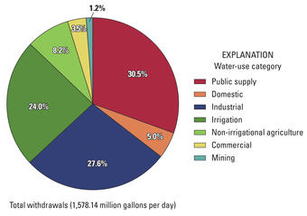

- Agricultural Use
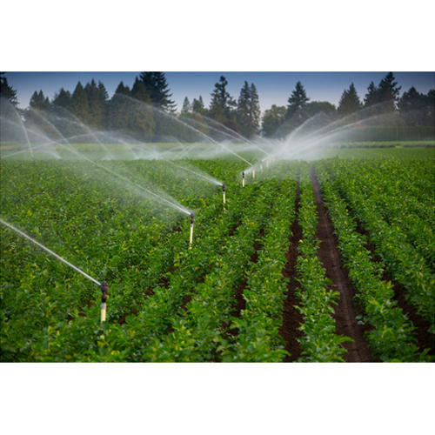
It accounts for around 71% of water is used for agriculture around the world, the main purpose of water in agriculture is for irrigation system. Most of the water for irrigation water comes from the river or ground-water. That the reason rivers are like lifeline for farmers in most of the countries like India, South Africa so on. And with the use of this system they save water a way better than before systems. And play vital role in water cycle.
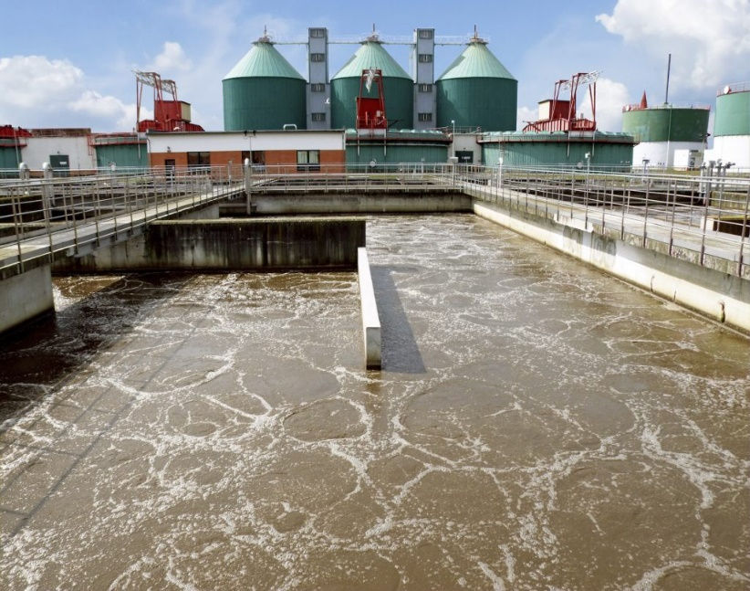
- Industrial Use
Industrial use of water includes water used for the purpose of washing, fabrication, transporting, diluting, manufacturing and processing of various products. The main use of water in some countries is for producing of electricity in thermal power plant and is also used in paper industries also. But as the increase of industrial use, they start throwing their waste in running water which is becoming a great problem around the world now a days.
Now lets talk about Water Pollution.
Water pollution is one of the main problems facing by the world now a days among all major problems. There are five main type of water pollution
- Domestic sewage:
This kind of waste are generated by household activities like wasting more amount of water in cleaning utensils or clothes, urine, laundry waste etc. this type of waste can produce waterborne diseases like dengue, malaria or can create hygiene problems which can make people sick and can pollute water can nobody can drink that water again.
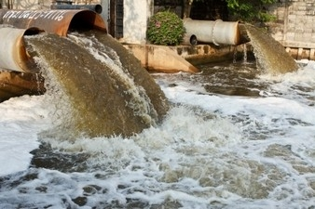

- Industrial Waste:
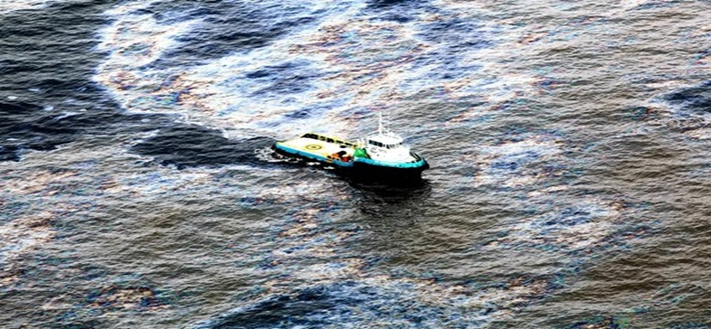
As I talk ahead that as use of water increases in chemical industries. The outcome of chemical bases waste also increases. Many companies all over the world started to decompose their waste materials into rivers which took them into sea and create a great lose in marine world. because of this many marine animals are dead because of getting polluted water. And as it is coming in news also that Oil industries while taking out crude oil from the sea was exploded couple of years ago which create a great lost in sea animals’ lives and can damage water of oceans.
- Agriculture waste:
Agriculture waste contains waste produce from pesticide, chemical fertilizer, manure, or by adding certain chemical in water to save crops from insects and birds. These things when goes to near by pond or lake which can pollute that lake and cannot use that water for any other purpose.
- Acid rain:
When sulphur dioxide and nitrogen oxides mix into atmosphere due to emission from industries or from vehicles which creates acid rain and when it merges into the fresh water supplies, which can spoil the fresh water and turn that into acidic water which does not use in further use and can create various skin diseases.
- Global warming:
Global warming is the one of the most horrible problem facing by the world. It occurs because of carbon dioxide increase in atmosphere which create a layer from which sunlight cannot pass in and which increase the water temperature of surface level.

Now lets talk about controlling of water pollution.
There are many ways of controlling water pollution by different sectors like
- Sewage waste control:
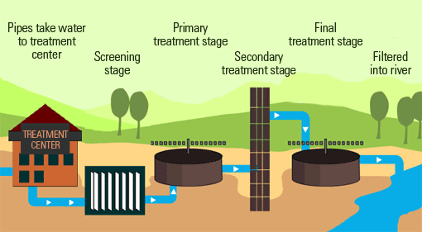
In this system there is a main role of government, by developing the sewage plants near the urban areas. According to this plant the sewage water is taken from one end of the industry and all the plastic material and all glass products are separated from water and then it passed over to another stage as shown below in the picture then afterward it goes into the secondary treatment stage where water is boiled of certain Celsius to destroy germs and bacteria then it is pass further into the river and we can use that water again. I believe this plant cost more to the government as they are getting enough tax from people for the settlement of this project.
- Industrial waste control.
As government can banned those company which waste are very hard to destroy, or they can put some precautions like limited amount of waste is acceptable per month or etc. As they can start programs like hazardous waste programs and so on which can help them in stopping to throw waste into rivers and seas to avoid them spoiling water resources. And there are many more plants like oil plants which separates oil from wastewater and some plants separate salt while heating water at certain temperature and then reuse that salt in industries. Carbon filtration plant to remove carbon form water and can reuse that water.
- Other government programs:
There are many other programs running now a days around the world which helps in saving water for our further generations like Rain water harvesting: in this programs after first rain in countries like India and Africa and China and many more countries having proper rain fall during rainy season they create and area on which they can put rain water and store that water for further purpose. Or they are helping people to get knowledge about various type of programs like in farming one can adopt dripping irrigation which can help in wasting of water. Or they can start putting the water which is left after dinking.

In conclusion, there are many uses of water as compare there are many ways to waste water and many ways to pollute water you can say because of human living sense, don’t care for someone. After few decades they will realise without water there is no use of living so they must have save water before. Water is life and life without water is waste.

REFERENCES:
https://en.wikipedia.org/wiki/Wastewater_treatment#Industrial_wastewater_treatment_plants
https://en.wikipedia.org/wiki/Water_pollution#Agricultural_wastewater_treatment

